**CI / CD IN DEVOPS:**  
  
**I) WATERFALL MODEL:**  
  
 Development happens in step by step manner.

Requirement analysis

Maintenance

Development

Design

Testing

**REQUIREMENTS ANALYSIS :**

Client

Programmer

requirements

Programmer accepts the clients requirements and analyze it.  
  
**DESIGN :**

Client

Programmer

requirements

Project Plan

Programmers then come up with a project plan & design architecture.

**DEVELOPMENT :**

Client

Programmer

requirements

Project Plan

Programmers code according to the plan

Application

Programmers code the application as per project plan & application

**TESTING :**

Client

Programmer

requirements

Project Plan

Programmers code according to the plan

Application

Testing

Testing ensures the application is error free & meets the requirements.

**MAINTENANCE :**

Client

Programmer

requirements

Project Plan

Programmers code according to the plan

Application

Testing

Application delivered to the client

After the application is delivered the operations team maintains the application.

**DISADVANTAGES :**

Product delivered requirements

Client

Programmer

Restart Development

List of changes

* Client requirements cannot be understood at once
* It is very expensive to make changes during the end of project
* Software must be delivered faster & with less resources

**2) AGILE MODEL:**

Programmers create prototype to understand client’s requirements.

Prototype

Client

Programmer

requirements

Client

Programmer

Prototype

Feedback

The entire process of building a software is broken down into small actionable blocks called **sprints**.

Review

Test

Code

Plan

Features of work from small to large such as bug fixing is known as **backlogs**.

Product Review

Deliverable Product

Sprint

Sprint Backlog

Sprint Planning

Product Backlog

Daily Scrum

**ADVANTAGES OF AGILE:**

* Client requirements are better understood because of constant feedback
* Product is delivered much faster when compared to waterfall model

**DISADVANTAGES OF AGILE:**

* The product gets tested on developer computers not on production environment
* Developers & operations team work in silos

**Process:**

Production Server

Operations

Developer

Product

* Developers submit the code to the operations team for deployment
* When the production fails in production server , the operations team are clueless & sents the product back to the development team.

**DEVOPS :**

* Devops is an evolution from agile model of software development
* Agile address gap between client & developers

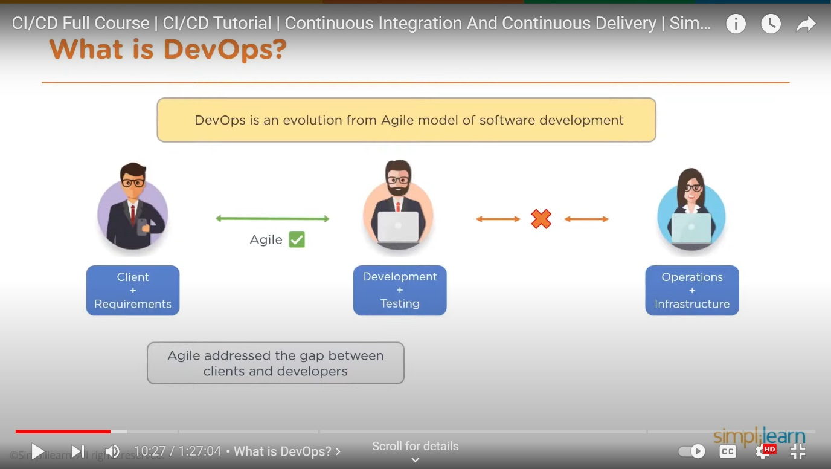

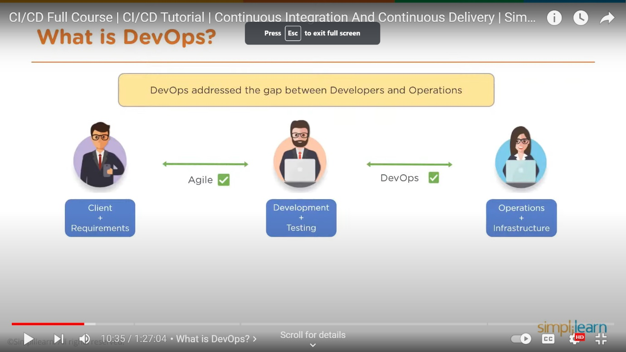

Devops address the gap between developers & operations.

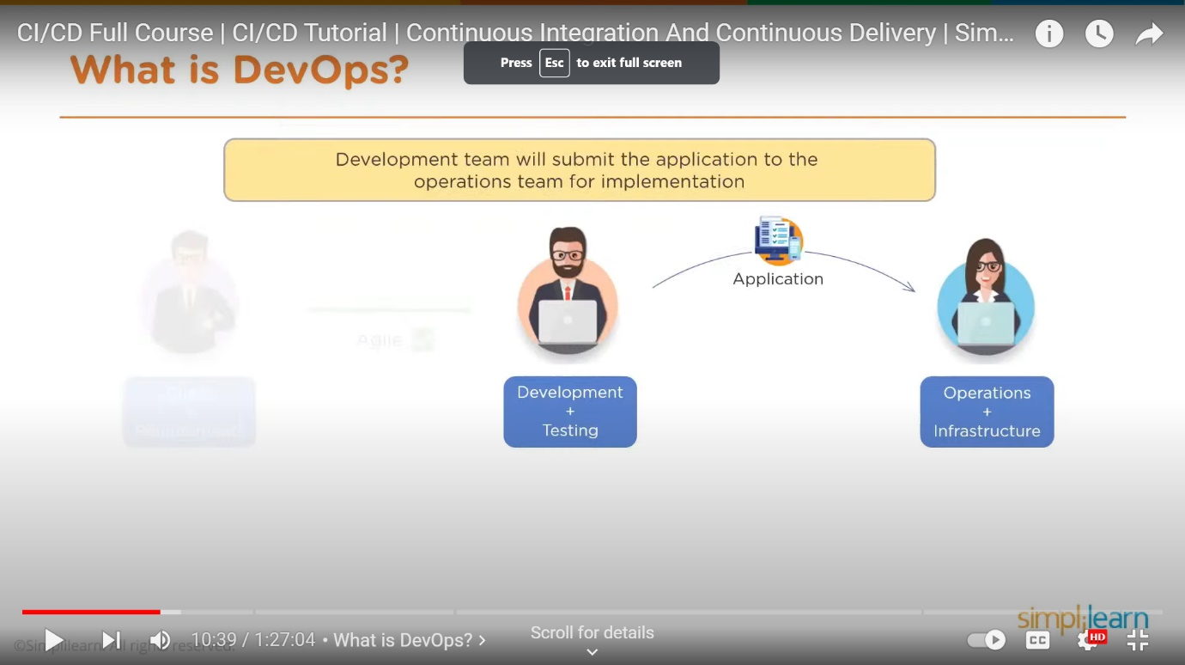

Development team will submit the application to the operations team for implementation.

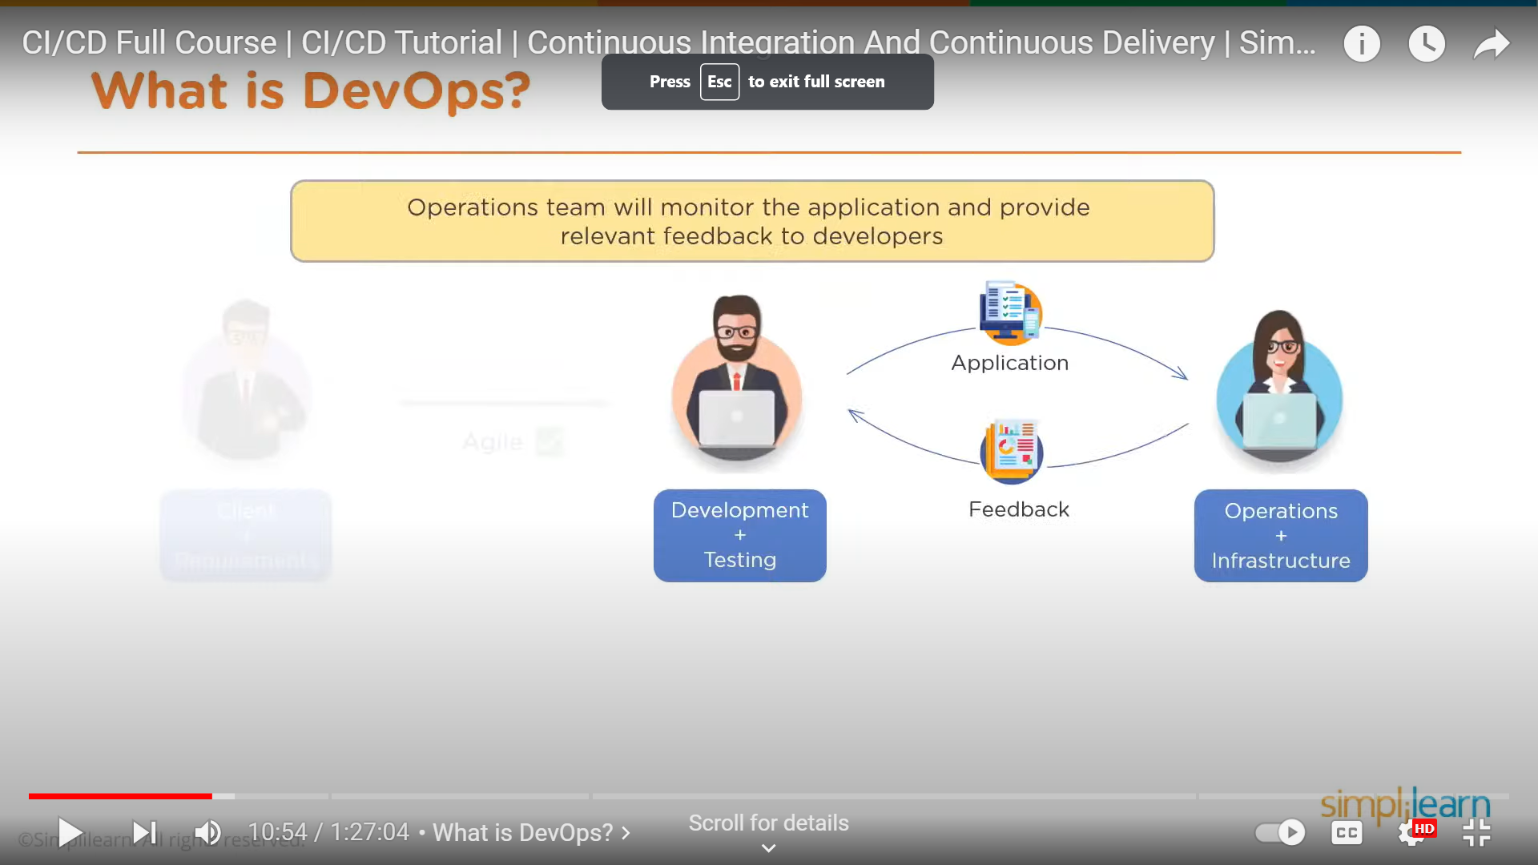

Operation team wil monitor the application & provide relevant feedback to the developers.

**PHASES:**

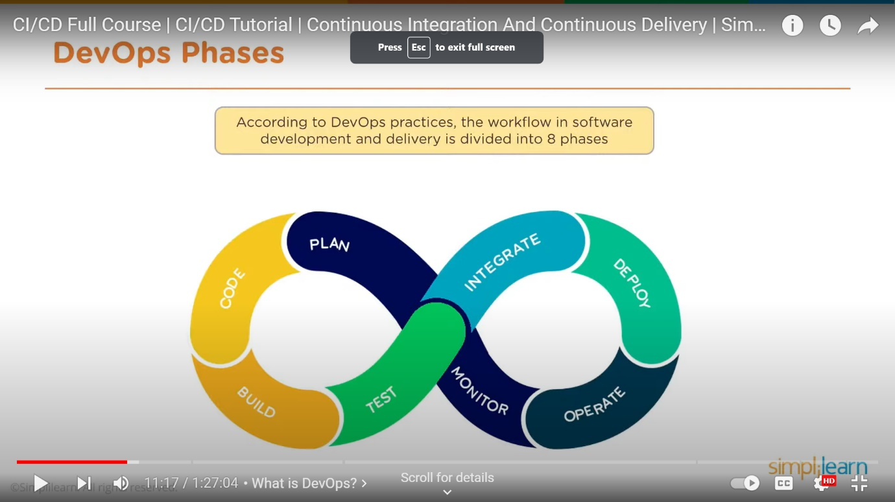

**PLAN :**

In plan stage , business owners and software development team discuss project goals and create a plan.

**CODE:**

Programmers then design & code the application & use tools like Git to store application code

**BUILD:**

Build tools like Maven & Gradle, Take code from different repoisitories and combine them to build the complete application.

**TEST:**

Application is tested using automation testing tools like selenium & junit to ensure software quality

**INTEGRATE:**

When testing is complete, new features are integrated automatically to the already existing codebase.

**DEPLOY:**

Application is packaged after release & deployed from development server to production server.

**OPERATE:**

Once the software is deployed, operations team performs activities such as configuring servers & provisioning them with the required resources.

**MONITOR:**

Monitoring allows IT Organization to identify specific issues of specific releases & understand the impact on end-users.

**DEVOPS TOOLS:**

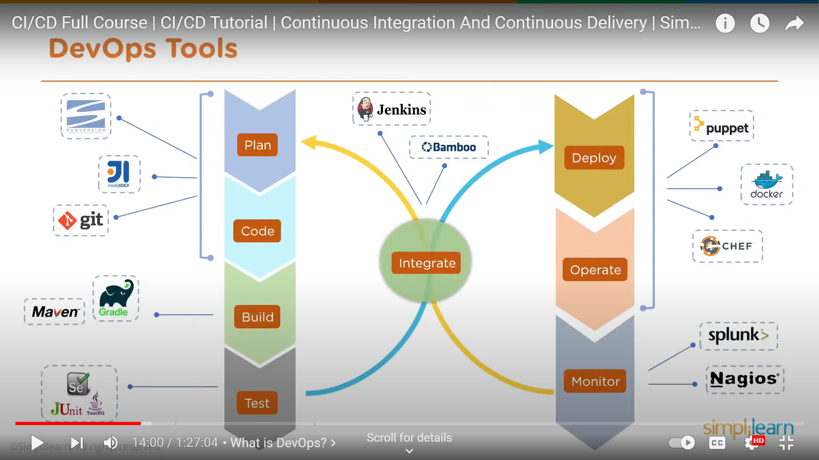

**DEVOPS PROCESS:**

**CONTINUOUS DELIVERY:**

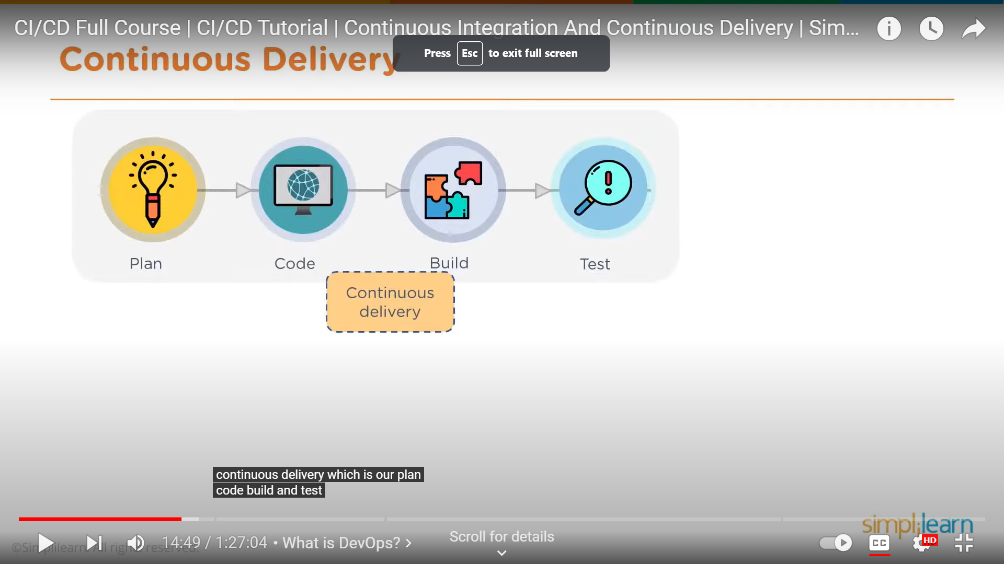

**CONTINUOUS INTEGRATION:**

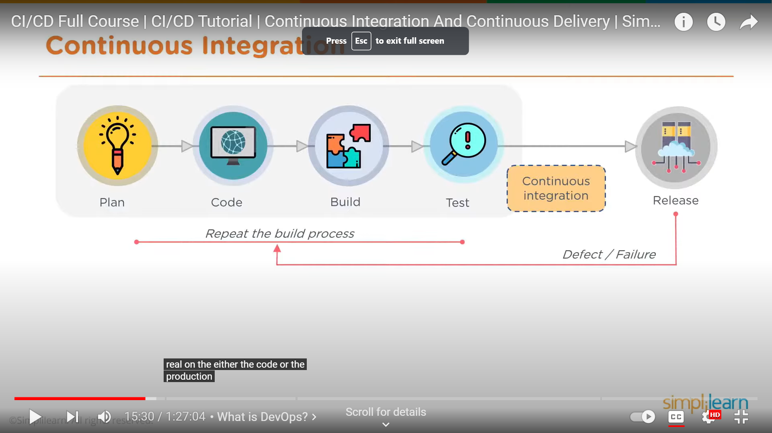

**CONTINUOUS DEPLOYMENT:**

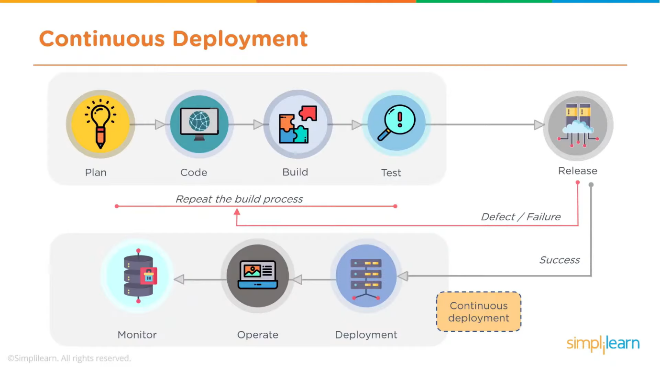

**ADVANTAGES OF DEVOPS:**

* Time taken to create & deliver software is reduced
* Complexity of maintaining an application is reduced
* Improved collaboration between developers & operations team
* Continuous integration & delivery ensures faster time to market

**CONTINUOUS INTEGRATION:**

Continuous integration is a development practice of code integration into a shared repoisitory. Each integration is verified by an automated build & automated test.

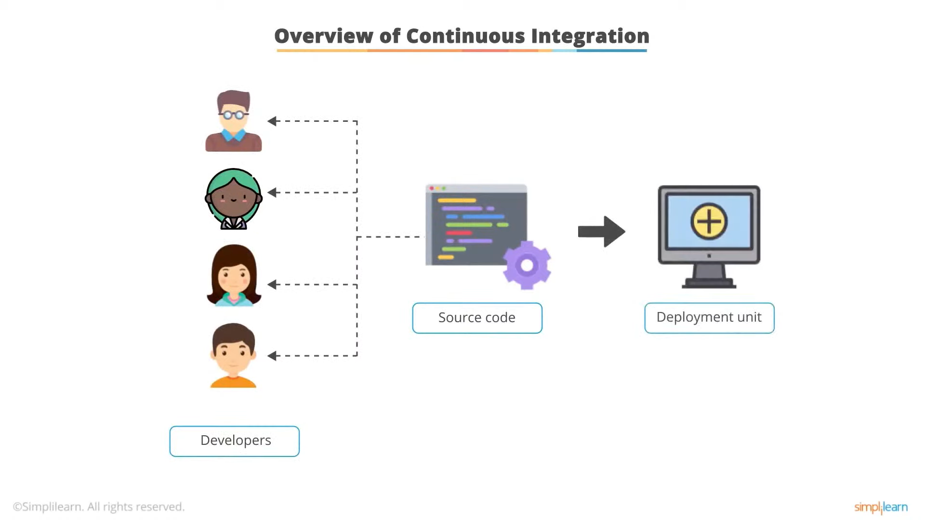

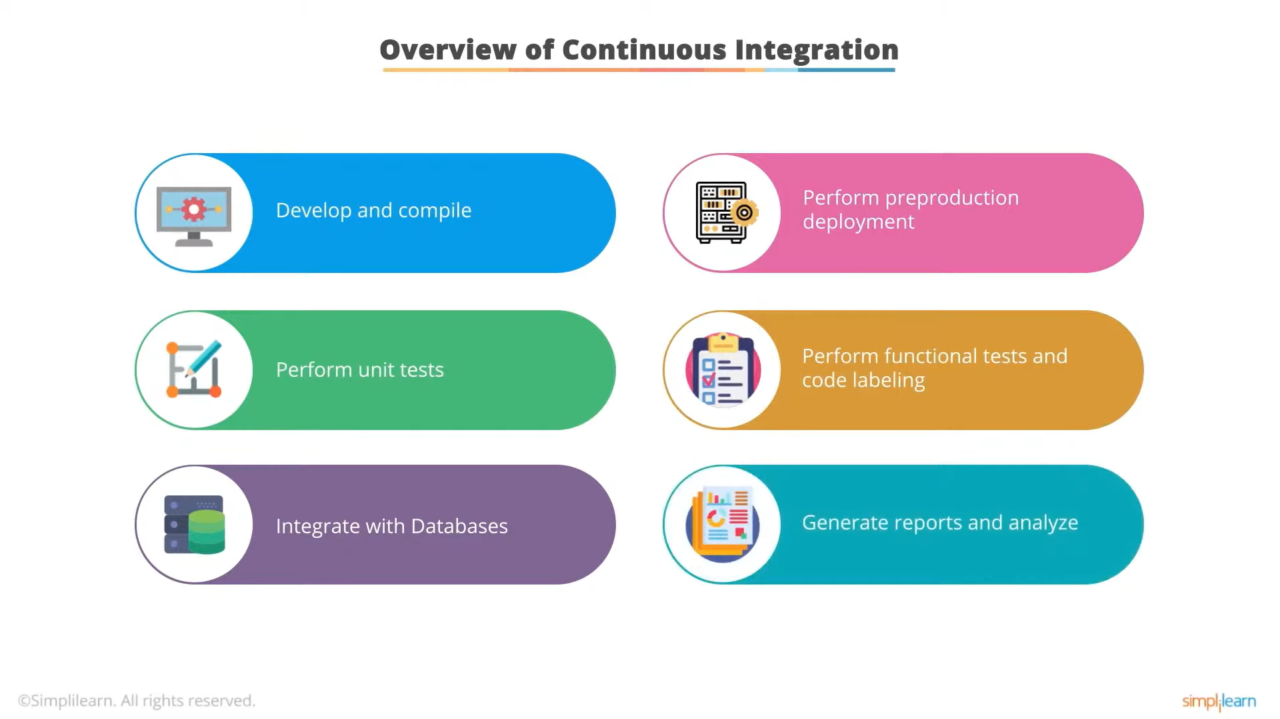

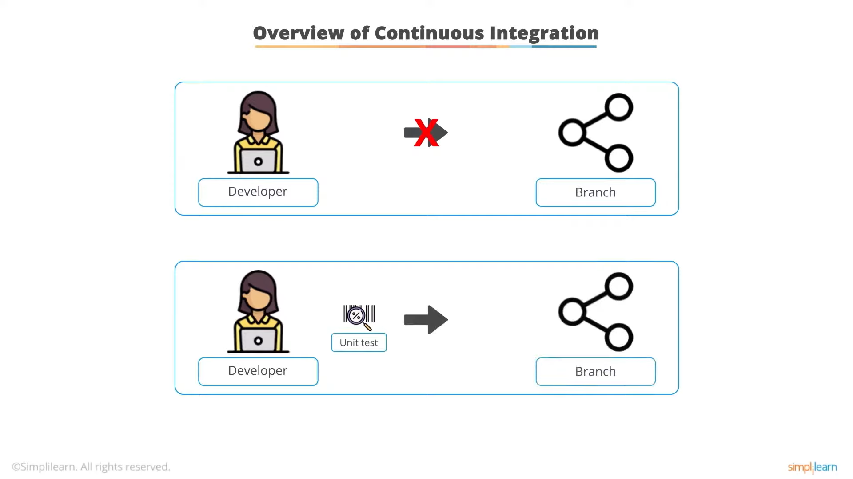

**CONTINUOUS DEPLOYMENT:**

Continuous deployment is the extension of continuous integration. It helps to reduce the time deployment team takes between writing one line of code & using it in production.

**BENEFITS OF CONTINUOUS DEPLOYMENT:**

Faster feedback from end users on each new feature as it is released to production.

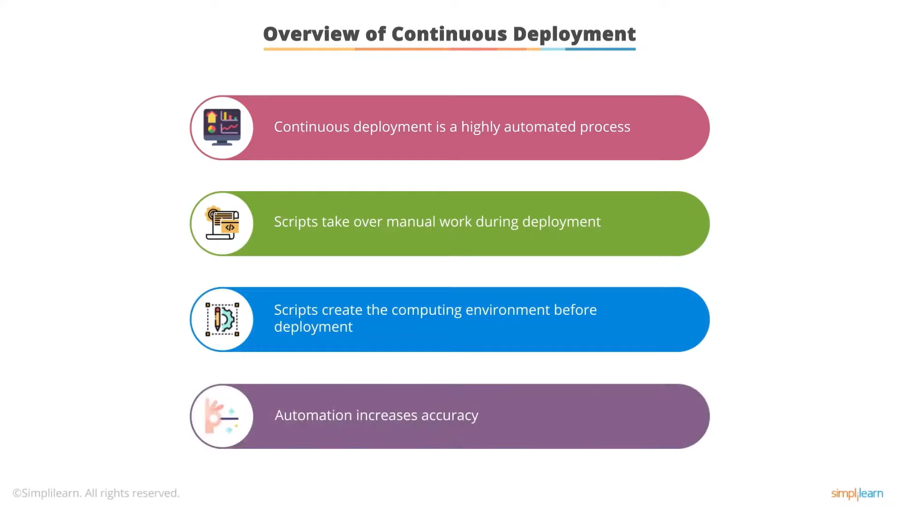

**CONTINUOUS DELIVERY VS CONTINUOUS DEPLOYMENT:**

|  |  |
| --- | --- |
| **CONTINUOUS DELIVERY** | **CONTINUOUS DEPLOYMENT** |
| Software delivery process where code changes are prepared to be released. | Practice that aims at continuously releasing the code changes into the production environment. |
| **ADVANTAGES:**   * Frequent releases * Releases completed in smaller segments. * Instant responses to defects/bugs. * More stable, reliable & comfortable releases. | **ADVANTAGES:**   * Completion of each deployment phase * Quick & more reliable completion. * Automation of the entire process. * Creation of fully automated ci/cd pipeline. |
| **FOR WHOM:**  Organizations that require release of new feature on a frequent basis. | **FOR WHOM:**  Organizations that require release of new feature on a daily or hourly basis. The process ensures cross department coordination. |

**HOW ARE CI & CD RELATED:**

